**DevOps Assignment**

Q) Install PostgreSQL and write a database backup script using bash.

**=>**

**webonise@webonise:~$ sudo -i -u postgres**

**[sudo] password for webonise:**

**postgres@webonise:~$ createdb Webonators**

**postgres@webonise:~$ psql Webonators**

**psql (12.9 (Ubuntu 12.9-0ubuntu0.20.04.1))**

**Type "help" for help.**

**Webonators=# create table students(rollno integer primary key, name varchar(40));**

**CREATE TABLE**

**Webonators=# \d students**

**Table "public.students"**

**Column | Type | Collation | Nullable | Default**

**--------+-----------------------+-----------+----------+---------**

**rollno | integer | | not null |**

**name | character varying(40) | | |**

**Indexes:**

**"students_pkey" PRIMARY KEY, btree (rollno)**

**Webonators=# insert into students values (1,'Aakash');**

**INSERT 0 1**

**Webonators=# insert into students values (2,'Abhishek');**

**INSERT 0 1**

**Webonators=# insert into students values (3,'Achal');**

**INSERT 0 1**

**Webonators=# select * from students;**

**rollno | name**

**--------+----------**

**1 | Aakash**

**2 | Abhishek**

**3 | Achal**

**(3 rows)**

**Webonators=# select * from students where rollno=2;**

**rollno | name**

**--------+----------**

**2 | Abhishek**

**(1 row)**

**Screenshots of DATABASES:**

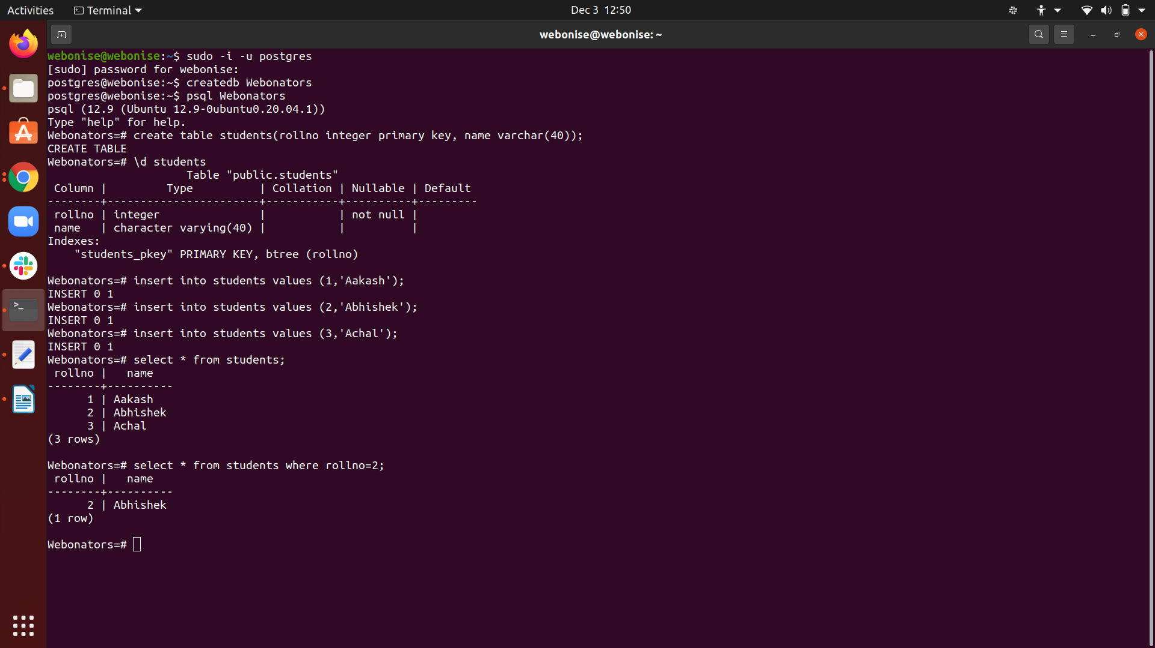

* Q) Install Mysql and write a database backup script using bash.

=>

-sudo apt update

-sudo apt install mysql-server -y

-sudo mysql -u root

Screenshots :

